

Job Pack

All you need to know about working for Aaina Community Hub.

**For more information, contact 01922 644006**

**Find us at: https://aainahub.com/**

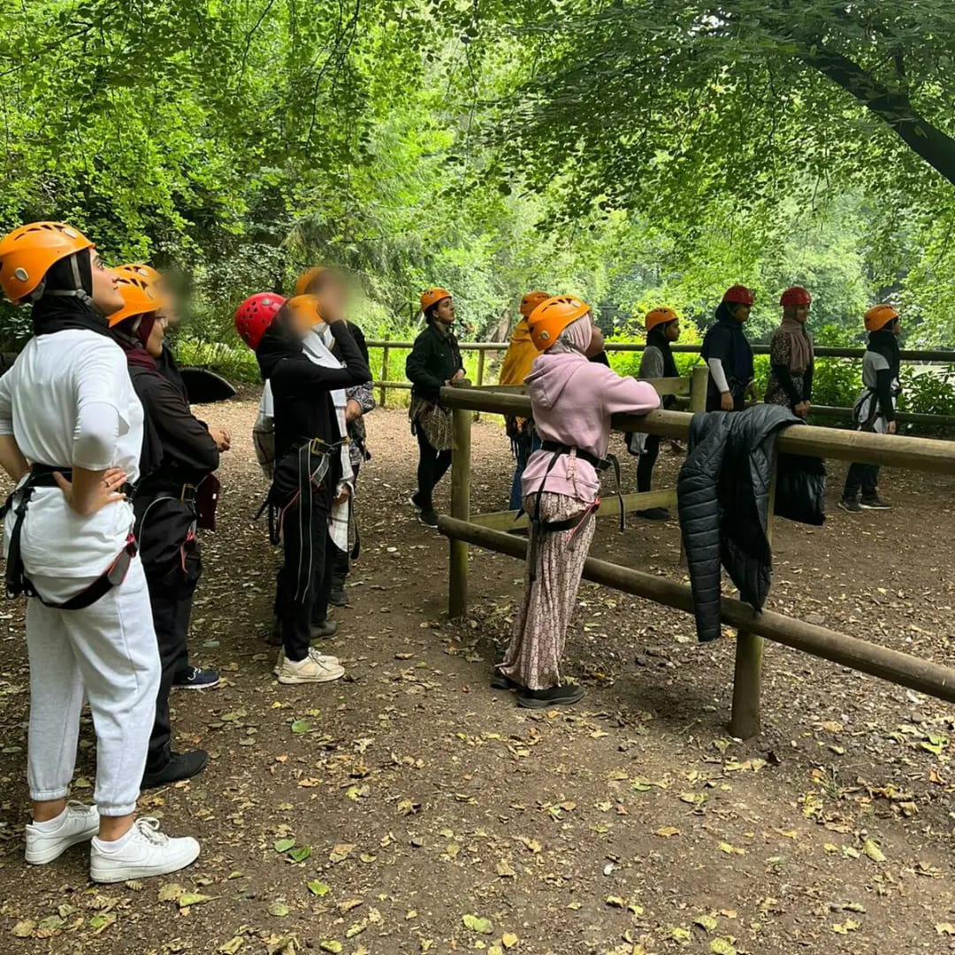

**Introduction**

We are delighted you are considering applying for a role at the Aaina Community Hub. Aaina delivers preventative and intervention focused life-enhancing opportunities for women and children, empowering through education, employment, advice and healthy lifestyles in a safe and supportive environment. We are looking for an enthusiastic person to join our team. This information pack contains important information about Aaina and the specific role you will be applying for. Please read it carefully to learn about the role & company.

Aaina has been delivering services for residents of Walsall since 1997, we specialise in providing access to education and training, accessing employment, support services and community engagement.

**Our Aim**

To play a dynamic role in enhancing quality of life by providing education, work skills and addressing inequalities in a supportive environment leading to improved life chances for the women of Walsall and their families.

**Mission Statement:**

Aaina Community Hub is committed to creating a nurturing environment where women and their families can thrive together. Our mission is to promote inclusivity, empower personal growth, and build a strong community foundation. We believe in the power of unity and the potential of every individual to make a positive impact, ensuring every voice is heard and every dream has the chance to flourish.

**Our Values**

* Inclusive - To ensure Aaina Community Hub fosters an inclusive environment that welcomes and supports all women and families accessing our services and space
* Ethical / integrity – Our ethical approach to service delivery is reflective in our integrity and commitment to transparency and honesty.
* Equitable – We are committed to recognising individual strengths and capabilities and accommodating beneficiaries accordingly
* Empowering – We recognise women’s power and provide them with the space and platform to reclaim this in a safe and supportive environment
* Self-Worth – instilling self-respect and self-worth in beneficiaries is fundamental for them to thrive and lead independent lives with self-belief and strength
* Opportunities – Aaina is committed to making opportunities accessible to beneficiaries that develop skills, wellbeing and prosperity and lead to individual progress.



Aaina has secured Youth Futures Foundation funding for a 4-year programme as part of the Connected Futures programme.

Aaina has identified three key objectives for the young people that will be targeted:

* An increase in Walsall’s 16-24 employment rate for young people with Bangladeshi and Pakistani heritage.
* Greater diversity of opportunity, including access to progression, as a result of changes in employer practice.
* Increased access to skills and training opportunities.

The aim will be to create employer-led momentum for change, through building relationships with employers, supported by wider strategic alliances. This partnership will broker direct engagement between employers and young people in the community – both to access opportunities and to influence thinking and practice.

This will be achieved through three workstreams:

* **Employer engagement** – Building ownership among local employers of the business benefits of a diverse workforce and the practical steps they can take to develop more inclusive employment practices.
* **Youth voice and engagement** – Providing outreach and brokerage with young people with Bangladeshi and Pakistani heritage, including those currently in low-paid employment, to promote access to training and progression opportunities.
* **Systems engagement** – Tackling systemic barriersin schools, colleges / training providers or families, as well as mainstream employment support, which limit young people’s exposure and/or access to opportunities.

We are keen to recruit a dynamic and committed team that will commence delivery from January 2024, staff will be primarily based at The Digital Hub on St Georges Street in Walsall.

**Being Part of the Team**

At Aaina we want to see people grow and succeed ad to thrive in their roles which is firmly aligned with our values. We expect everyone to display the behaviours need to contribute to our vision and purpose. In return we seek to offer an inclusive, rewarding and collaborative environment.

**Staff Benefits**

* 28 days annual leave, plus England public holidays per year (pro rata if part time)
* Mid and annual performance review with development plans
* Access to mandatory and ongoing personal development training
* NEST employer contribution scheme
* Mental Health and Wellbeing support including a trained mental health first aider within the team
* Office closure between Christmas and New Year
* We accommodate school pick-ups and drop offs
* Team building sessions throughout the year
* Mentoring and Coaching opportunities

**Job description**

**Position title:** Finance Officer

**Salary:** £28,860 pro rata (£15.00per hour)

**Hours of work:** 18 hrs per week

**Duration:** 4 Years

**Place of Work:** Located at the AAINA Community Hub, WS1 3BS Job

**Summary:**

To provide financial administration support to the organisation, oversee project income expenditure, process invoices and responsible for managing financial records, ensuring compliance with financial regulations, and providing financial insights that support decision-making.

**Key Responsibilities**

Financial Management: Maintain accurate financial records and ensure the integrity of financial data. Oversee accounts payable and receivable, ensuring timely processing of invoices and payments.

### Skills and Qualifications

#### Education:

* Relevant qualifications in finance, accounting, business administration, or a related field.

#### Experience:

* Proven experience in a finance or accounting role, preferably within the same industry.
* Experience with financial reporting, budgeting, and financial analysis.
* Finance administration in a community setting desirable

#### Skills:

* **Analytical Skills:** Ability to analyse financial data and provide actionable insights.
* **Attention to Detail:** High level of accuracy and attention to detail in financial record-keeping and reporting, raising invoices and record keeping and preparing income and expenditure for projects.
* **Technical Proficiency:** Proficiency in accounting software (e.g., QuickBooks, SAP, Oracle) and MS Office Suite (particularly Excel).
* **Communication:** Strong verbal and written communication skills to effectively convey financial information.
* **Problem-Solving:** Ability to identify financial issues and develop solutions.

#### Attributes:

* **Integrity:** Strong ethical standards and integrity in handling financial data.
* **Organisational Skills:** Excellent organisational and time-management abilities.
* **Adaptability:** Flexibility to adapt to changing financial environments and regulations.

**Aaina’s Commitment to Diversity**

Aaina Community Hub is committed to creating a diverse environment and is proud to be an equal-opportunity employer. All qualified applicants will receive consideration for employment without regard to race, ethnicity, religion, gender, gender identity or expression, sexual orientation, national origin, genetics, disability, or age.

**How to apply**

To apply for this post, download the application form, please email completed application form to [**info@aainahub.com**](mailto:info@aainahub.com)

Call **01922 644006** for any further information if you require any assistance or adjustment so that can help with making the application process work for you.

For any questions or to arrange an informal chat about this role, email CEO A’isha Khan at aishakhan@aainahub.com

**Deadline for applications**

Friday 3rd January

**Interviews to be held**

W/C Monday 13th January 2025

**Decision made by**

W/C 20th January 2025