

Job Pack

All you need to know about working for Aaina Community Hub.

**For more information, contact 01922 644006**

**Find us at: https://aainahub.com/**

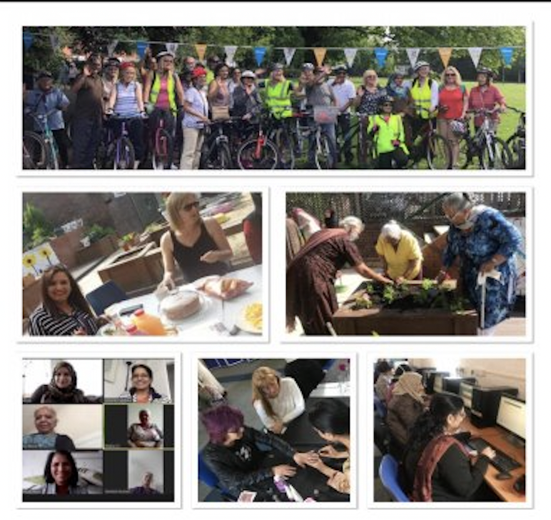

**Introduction**

We are delighted you are considering applying for a role at the Aaina Community Hub. Aaina delivers preventative and intervention focused life-enhancing opportunities for women and children, empowering through education, employment, advice and healthy lifestyles in a safe and supportive environment. We are looking for an enthusiastic person to join our team. This information pack contains important information about Aaina and the specific role you will be applying for. Please read it carefully to learn about the role & company.

Aaina has been delivering services for residents of Walsall since 1997, we specialise in providing access to education and training, accessing employment, support services and community engagement.

**Our Aim**

To play a dynamic role in enhancing quality of life by providing education, work skills and addressing inequalities in a supportive environment leading to improved life chances for the women of Walsall and their families.

**Mission Statement:**

Aaina Community Hub is committed to creating a nurturing environment where women and their families can thrive together. Our mission is to promote inclusivity, empower personal growth, and build a strong community foundation. We believe in the power of unity and the potential of every individual to make a positive impact, ensuring every voice is heard and every dream has the chance to flourish.

**Our Values**

* Inclusive - To ensure Aaina Community Hub fosters an inclusive environment that welcomes and supports all women and families accessing our services and space
* Ethical / integrity – Our ethical approach to service delivery is reflective in our integrity and commitment to transparency and honesty.
* Equitable – We are committed to recognising individual strengths and capabilities and accommodating beneficiaries accordingly
* Empowering – We recognise women’s power and provide them with the space and platform to reclaim this in a safe and supportive environment
* Self-Worth – instilling self-respect and self-worth in beneficiaries is fundamental for them to thrive and lead independent lives with self-belief and strength
* Opportunities – Aaina is committed to making opportunities accessible to beneficiaries that develop skills, wellbeing and prosperity and lead to individual progress.

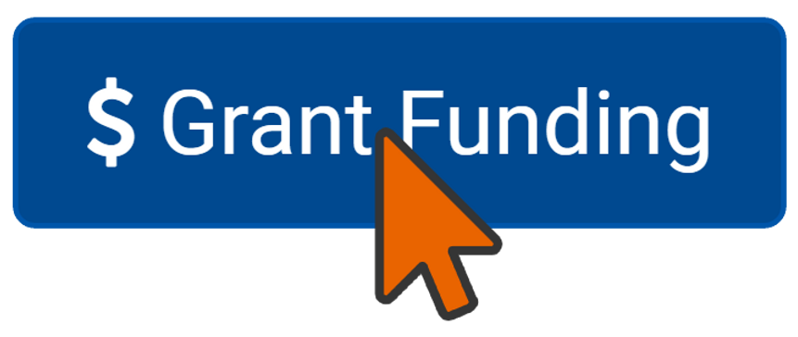

**Being Part of the Team**

At Aaina we want to see people grow and succeed ad to thrive in their roles which is firmly aligned with our values. We expect everyone to display the behaviours need to contribute to our vision and purpose. In return we seek to offer an inclusive, rewarding and collaborative environment.

**Staff Benefits**

* 28 days annual leave, plus England public holidays per year (pro rata if part time)
* Mid and annual performance review with development plans
* Access to mandatory and ongoing personal development training
* NEST employer contribution scheme
* Mental Health and Wellbeing support including a trained mental health first aider within the team
* Office closure between Christmas and New Year
* We accommodate school pick-ups and drop offs
* Team building sessions throughout the year
* Mentoring and Coaching opportunities

**Job Description : Grant Funding Officer**

**Reports to: CEO**

**Salary:** £23,523.00 per annum

**Hours:** 30hrs per week

**Duration:** 12 month fixed term contract subject to successful securingof funding

**Job Purpose:**

**Position Overview:** The Grant Funding Officer is responsible for identifying, acquiring, and managing grant funding to support the organisation's initiatives in education, training, health, and community engagement (please go to our website wwwaainahub.com for further information about the services we deliver). This role involves researching funding opportunities, writing proposals, ensuring compliance with funding requirements, and building relationships with funders and community stakeholders.

**Key Responsibilities:**

1. **Grant Research and Identification:**
   * Conduct comprehensive research to identify funding opportunities that align with the organisation's mission and programs.
   * Keep abreast of current trends in grant funding and relevant issues in education, health, and community services.
2. **Proposal Development:**
   * Write and edit compelling grant proposals that effectively communicate the organization’s needs, goals, and impact to potential funders.
   * Collaborate with program staff to gather data, budget information, and narrative content necessary for proposals.
3. **Application Management:**
   * Manage the grant application process from start to finish, ensuring timely submission of proposals and compliance with funder requirements.
   * Maintain a detailed calendar of grant deadlines, reporting requirements, and follow-up actions.
4. **Grant Compliance and Reporting:**
   * Monitor the implementation of funded programs to ensure compliance with grant agreements and organisational policies.
   * Prepare and submit progress and final reports to funders detailing program outcomes and financial expenditures.
5. **Funders and Stakeholder Relations:**
   * Build and maintain relationships with current and prospective funders, community partners, and stakeholders to promote the organisation’s mission.
   * Attend networking events, workshops, and meetings to represent the organisation and seek new funding opportunities.
6. **Program Evaluation and Monitoring:**
   * Support the development of program evaluation plans to measure the impact and success of funded projects.
   * Analyze and report on program data to inform stakeholders about outcomes and improvements.
7. **Capacity Building and Training:**
   * Provide training and guidance to staff on effective grant writing and management practices.
   * Share best practices for grant compliance and reporting with relevant team members.

**Qualifications**

1. Bachelor’s degree in nonprofit management, finance, public administration, social sciences, or a related field.
2. At least 2 years of experience in grant writing, fundraising, or related activities in the nonprofit sector.
3. Proven ability to write successful grant proposals and reports, with strong attention to detail.
4. Excellent organizational and project management skills.
5. Strong interpersonal skills with the ability to build relationships with diverse stakeholders.
6. Familiarity with budgeting and financial reporting.
7. A passion for community service and understanding of the challenges faced by underserved populations.

No job description can be entirely comprehensive and the jobholder will be expected to adapt and carry out such other duties as may be required from time to time, on the understanding that they will be within the individual’s remit and capability, and consistent with the status and responsibilities of the role within the organisation.

This post is advertised in accordance with section 7.2 (e) of the Sex Discrimination Act. Only women need to apply. Registered charity number: 1112663

**Aaina’s Commitment to Diversity**

Aaina Community Hub is committed to creating a diverse environment and is proud to be an equal-opportunity employer. All qualified applicants will receive consideration for employment without regard to race, ethnicity, religion, gender, gender identity or expression, sexual orientation, national origin, genetics, disability, or age.

**How to apply**

To apply for this post, download the application form, please email completed application form to [**info@aainahub.com**](mailto:info@aainahub.com)

**Recruitment timetable Additional Support / information**

Call **01922 644006** for any further information if you require any assistance or adjustment so that can help with making the application process work for you.

For any questions or to arrange an informal chat about this role, email CEO A’isha Khan at aishakhan@aainahub.com

**Deadline for applications**

Friday 3rd January

**Interviews to be held**

W/C Monday 13th January 2025

**Decision made by**

W/C 20th January 2025