

Job Pack

All you need to know about working for Aaina Community Hub.

**For more information, contact 01922 644006**

**Find us at: https://aainahub.com/**

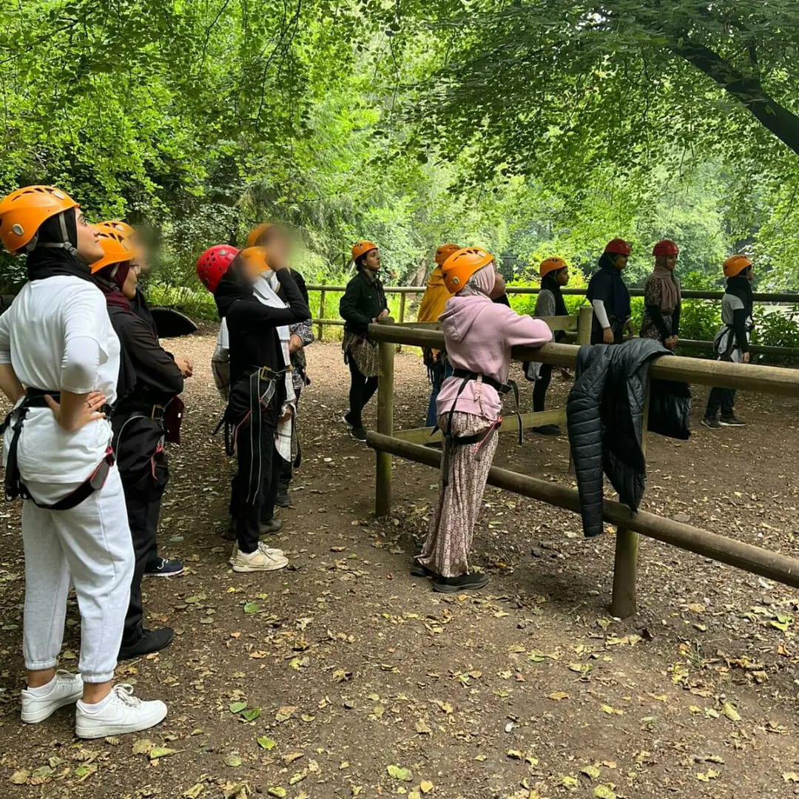

**Introduction**

We are delighted you are considering applying for a role at the Aaina Community Hub. Aaina delivers preventative and intervention focused life-enhancing opportunities for women and children, empowering through education, employment, advice and healthy lifestyles in a safe and supportive environment. We are looking for an enthusiastic person to join our team. This information pack contains important information about Aaina and the specific role you will be applying for. Please read it carefully to learn about the role & company.

Aaina has been delivering services for residents of Walsall since 1997, we specialise in providing access to education and training, accessing employment, support services and community engagement.

**Our Aim**

To play a dynamic role in enhancing quality of life by providing education, work skills and addressing inequalities in a supportive environment leading to improved life chances for the women of Walsall and their families.

**Mission Statement:**

Aaina Community Hub is committed to creating a nurturing environment where women and their families can thrive together. Our mission is to promote inclusivity, empower personal growth, and build a strong community foundation. We believe in the power of unity and the potential of every individual to make a positive impact, ensuring every voice is heard and every dream has the chance to flourish.

**Our Values**

* Inclusive - To ensure Aaina Community Hub fosters an inclusive environment that welcomes and supports all women and families accessing our services and space
* Ethical / integrity – Our ethical approach to service delivery is reflective in our integrity and commitment to transparency and honesty.
* Equitable – We are committed to recognising individual strengths and capabilities and accommodating beneficiaries accordingly
* Empowering – We recognise women’s power and provide them with the space and platform to reclaim this in a safe and supportive environment
* Self-Worth – instilling self-respect and self-worth in beneficiaries is fundamental for them to thrive and lead independent lives with self-belief and strength
* Opportunities – Aaina is committed to making opportunities accessible to beneficiaries that develop skills, wellbeing and prosperity and lead to individual progress.

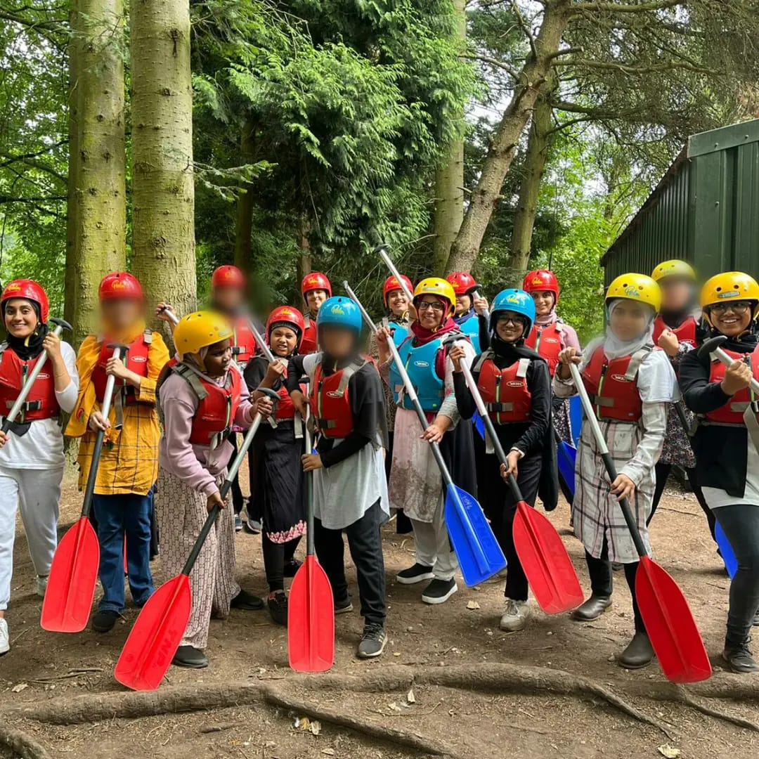

Aaina has secured Youth Futures Foundation funding for a 4-year programme as part of the Connected Futures programme.

Aaina has identified three key objectives for the young people that will be targeted:

* An increase in Walsall’s 16-24 employment rate for young people with Bangladeshi and Pakistani heritage.
* Greater diversity of opportunity, including access to progression, as a result of changes in employer practice.
* Increased access to skills and training opportunities.

The aim will be to create employer-led momentum for change, through building relationships with employers, supported by wider strategic alliances. This partnership will broker direct engagement between employers and young people in the community – both to access opportunities and to influence thinking and practice.

This will be achieved through three workstreams:

* **Employer engagement** – Building ownership among local employers of the business benefits of a diverse workforce and the practical steps they can take to develop more inclusive employment practices.
* **Youth voice and engagement** – Providing outreach and brokerage with young people with Bangladeshi and Pakistani heritage, including those currently in low-paid employment, to promote access to training and progression opportunities.
* **Systems engagement** – Tackling systemic barriersin schools, colleges / training providers or families, as well as mainstream employment support, which limit young people’s exposure and/or access to opportunities.

We are keen to recruit a dynamic and committed team that will commence delivery from January 2024, staff will be primarily based at The Digital Hub on St Georges Street in Walsall.

**Being Part of the Team**

At Aaina we want to see people grow and succeed ad to thrive in their roles which is firmly aligned with our values. We expect everyone to display the behaviours need to contribute to our vision and purpose. In return we seek to offer an inclusive, rewarding and collaborative environment.

**Staff Benefits**

* 28 days annual leave, plus England public holidays per year (pro rata if part time)
* Mid and annual performance review with development plans
* Access to mandatory and ongoing personal development training
* NEST employer contribution scheme
* Mental Health and Wellbeing support including a trained mental health first aider within the team
* Office closure between Christmas and New Year
* We accommodate school pick-ups and drop offs
* Team building sessions throughout the year
* Mentoring and Coaching opportunities

**Job Description**

**Position Title:** **Partnership Manager**

* **Salary:** £34,000.00 Per annum
* **Job type:** Full-time - 37 hrs per week
* **Duration:** Four-year programme to commence January 2024. Fixed annual contract reviewed annually based on performance and outputs and outcomes achieved
* **Place of Work:** Located at the Digital Hub, St Georges Street
* **Monday to Friday**: flexible approach required for evening/weekend

meetings/events

**Main purpose of the job role:**

We are looking for a Partnership Manager who is passionate and committed to improving opportunities for young people in the work place from Bangladeshi and Pakistani backgrounds, they will develop a local shared ambition for systems change and commitment to action.

The Partnership Manager will lead a team of staff to highlight and address Race Disparity in employment impacting young people from the Pakistani and Bangladeshi community in Walsall. They will be responsible for fostering collaborations and initiatives aimed at addressing and reducing racial disparities in the workforce as highlighted by the Ethnic Disparities Research [Narrowing the gap: tackling ethnic disparities in youth employment](https://youthfuturesfoundation.org/wp-content/uploads/2022/11/Youth-Futures-Foundation-Narrowing-the-gap-tackling-ethnic-disparities.pdf). The role involves working with a variety of stakeholders, including government agencies, non-profits, educational institutions, and private sector companies, to develop and implement strategies that promote diversity, equity, and inclusion in employment.

The suitable candidate will have a good understanding of EDI and passionate about addressing inequalities in employment that young people from specific ethnic minority communities experience.

### Key Responsibilities:

1. **Stakeholder Engagement:**
   * Develop and maintain relationships with Partner Organisations and Young People engaged with the project, providing support and direction as required
   * Liaise with key stakeholders, including employers, community organisations, educational institutions, and government agencies.
   * Organise and Facilitate discussions and collaborations between stakeholders to address race disparities in employment via regular meetings as per the project outcomes
2. **Project Delivery and Implementation:**
   * Responsible for the operational co-ordination of the project to implement project aims, engage with partner organisations, Youth Panel and Stakeholders to achieve project objectives
   * Provide team leadership and support to ensure all project staff achieve their targets and receive the necessary support and guidance.
   * Develop project plans, timelines, and budgets, ensuring alignment with organisational goals.
   * Oversee planning of quarterly job fairs and networking events in community spaces that are easily accessible to young people from the target group.
3. **Research and Analysis:**
   * Work closely with the YFF support team to capture information that will contribute to research and evaluation of the project to identify the root causes of racial disparities in employment.
   * Analyse and present data to measure the impact of programs and initiatives, making adjustments as necessary to improve outcomes.
4. **Advocacy and Awareness:**
   * Advocate for policies and practices that promote racial equity in the workplace.
   * Raise awareness about the issues of racial disparity in employment through public speaking, workshops, and seminars.
   * Increase awareness around the Race at work charter in local industry
5. **Monitoring and Reporting:**
   * Monitor the progress of initiatives and programs, providing regular updates and reports to stakeholders, this will include monthly reflections and quarterly updates.
   * Regularly assess project progress and make necessary adjustments based on feedback and evaluation outcomes
6. **Training and Development:**
   * Work closely with EDI leads to share best practice and training opportunities around equality, diversity and Inclusion available locally and regionally.
   * Share best practice with stakeholders and promote training and leadership opportunities linked to EDI.

### Skills and Qualifications:

1. **Education:**
   * A bachelor's degree in a related field, a master's degree can be an added advantage.
   * Strong understanding of racial disparities, social justice issues, and community engagement frameworks

**Main purpose of the job role:**

We are looking for a Partnership Manager who is passionate and committed to improving opportunities for young people in the work place from Bangladeshi and Pakistani backgrounds, they will develop a local shared ambition for systems change and commitment to action.

The Partnership Manager will lead a team of staff to highlight and address Race Disparity in employment impacting young people from the Pakistani and Bangladeshi community in Walsall. They will be responsible for fostering collaborations and initiatives aimed at addressing and reducing racial disparities in the workforce as highlighted by the Ethnic Disparities Research [Narrowing the gap: tackling ethnic disparities in youth employment](https://youthfuturesfoundation.org/wp-content/uploads/2022/11/Youth-Futures-Foundation-Narrowing-the-gap-tackling-ethnic-disparities.pdf). The role involves working with a variety of stakeholders, including government agencies, non-profits, educational institutions, and private sector companies, to develop and implement strategies that promote diversity, equity, and inclusion in employment.

The suitable candidate will have a good understanding of EDI and passionate about addressing inequalities in employment that young people from specific ethnic minority communities experience.

### Key Responsibilities:

1. **Stakeholder Engagement:**
   * Develop and maintain relationships with Partner Organisations and Young People engaged with the project, providing support and direction as required
   * Liaise with key stakeholders, including employers, community organizations, educational institutions, and government agencies.
   * Organise and Facilitate discussions and collaborations between stakeholders to address race disparities in employment via regular meetings as per the project outcomes
2. **Project Delivery and Implementation:**
   * Responsible for the operational co-ordination of the project to implement project aims, engage with partner organisations, Youth Panel and Stakeholders to achieve project objectives
   * Design and implement initiatives with stakeholders that aim to reduce racial disparities in the workforce.
   * Provide team leadership and support to ensure all project staff achieve their targets and receive the necessary support and guidance.
   * Develop project plans, timelines, and budgets, ensuring alignment with organisational goals.
   * Oversee planning of quarterly job fairs and networking events in community spaces that are easily accessible to young people from the target group.
   * Collaborate with local employers, training providers, and community organizations to secure participation in the job fairs and ensure a diverse range of opportunities are available.
3. **Research and Analysis:**
   * Work closely with the YFF support team to capture information that will contribute to research and evaluation of the project to identify the root causes of racial disparities in employment.
4. **Monitoring and Reporting:**
   * Monitor the progress of initiatives and programs, providing regular updates and reports to stakeholders, this will include monthly reflections and quarterly updates.
   * Regularly assess project progress and make necessary adjustments based on feedback and evaluation outcomes
5. **Training and Development:**
   * Share best practice with stakeholders and promote training and leadership opportunities linked to EDI.

### Skills and Qualifications:

1. **Education:**
   * A bachelor's degree in a related field, a master's degree can be an added advantage.
   * Strong understanding of racial disparities, social justice issues, and community engagement frameworks
2. **Experience:**
   * Significant experience in diversity, equity, and inclusion (DEI) initiatives, particularly related to employment.
   * Experience in project management, programme development, and stakeholder engagement.
3. **Skills:**
   * Strong written and verbal communication skills, with the ability to present information clearly.
   * Ability to analyse and interpret data.
   * Strategic thinking and problem-solving abilities.
   * Leadership and teamwork skills.
   * Cultural competence and sensitivity.
   * Organisational Skills: Strong planning, organisational, and multitasking abilities
4. **Knowledge:**
   * In-depth understanding of the issues and challenges related to racial disparities in employment.
   * Familiarity with relevant laws and regulations related to EDI.
   * Understanding of local Industry small and large
   * Awareness of the diverse make up of local communities and the issues that impact them in relation to employment and racial disparities.

**Special Conditions:**

Working outside of standard office hours may be required. There is a requirement to work flexibly at all times with due regard to prevailing workloads and priorities. Attendance at evening and other out-of-hour meetings as required by the project.

**Reporting Relationships:-**

Accountable to AAINA Community Hub

Reporting to CEO

**Aaina’s Commitment to Diversity**

Aaina Community Hub is committed to creating a diverse environment and is proud to be an equal-opportunity employer. All qualified applicants will receive consideration for employment without regard to race, ethnicity, religion, gender, gender identity or expression, sexual orientation, national origin, genetics, disability, or age.

**How to apply**

To apply for this post, download the application form, please email completed application form to [**info@aainahub.com**](mailto:info@aainahub.com)

**Recruitment timetable Additional Support / information**

Call **01922 644006** for any further information if you require any assistance or adjustment so that can help with making the application process work for you.

For any questions or to arrange an informal chat about this role, email CEO A’isha Khan at aishakhan@aainahub.com

**Deadline for applications**

Friday 3rd January

**Interviews to be held**

W/C Monday 13th January 2025

**Decision made by**

W/C 20th January 2025