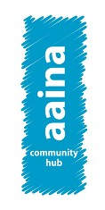

Job Pack

All you need to know about working for Aaina Community Hub.

**For more information, contact 01922 644006**

**Find us at: https://aainahub.com/**

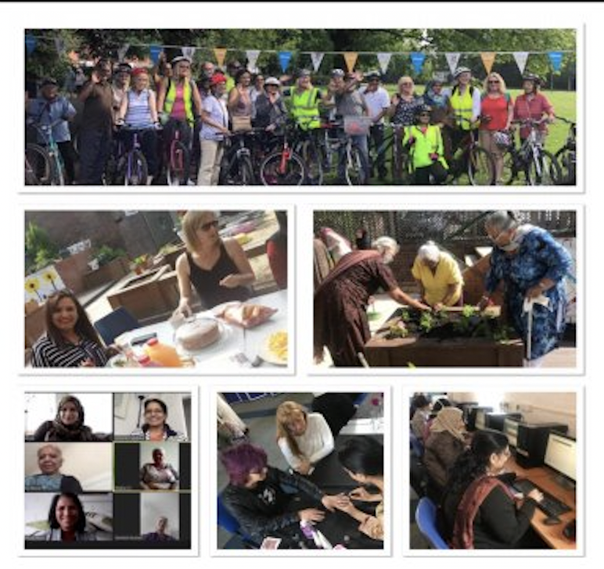

**Introduction**

We are delighted you are considering applying for a role at the Aaina Community Hub. Aaina delivers preventative and intervention focused life-enhancing opportunities for women and children, empowering through education, employment, advice and healthy lifestyles in a safe and supportive environment. We are looking for an enthusiastic person to join our team. This information pack contains important information about Aaina and the specific role you will be applying for. Please read it carefully to learn about the role & company.

Aaina has been delivering services for residents of Walsall since 1997, we specialise in providing access to education and training, accessing employment, support services and community engagement.

**Our Aim**

To play a dynamic role in enhancing quality of life by providing education, work skills and addressing inequalities in a supportive environment leading to improved life chances for the women of Walsall and their families.

**Mission Statement:**

Aaina Community Hub is committed to creating a nurturing environment where women and their families can thrive together. Our mission is to promote inclusivity, empower personal growth, and build a strong community foundation. We believe in the power of unity and the potential of every individual to make a positive impact, ensuring every voice is heard and every dream has the chance to flourish.

**Our Values**

* Inclusive - To ensure Aaina Community Hub fosters an inclusive environment that welcomes and supports all women and families accessing our services and space
* Ethical / integrity – Our ethical approach to service delivery is reflective in our integrity and commitment to transparency and honesty.
* Equitable – We are committed to recognising individual strengths and capabilities and accommodating beneficiaries accordingly
* Empowering – We recognise women’s power and provide them with the space and platform to reclaim this in a safe and supportive environment
* Self-Worth – instilling self-respect and self-worth in beneficiaries is fundamental for them to thrive and lead independent lives with self-belief and strength
* Opportunities – Aaina is committed to making opportunities accessible to beneficiaries that develop skills, wellbeing and prosperity and lead to individual progress.

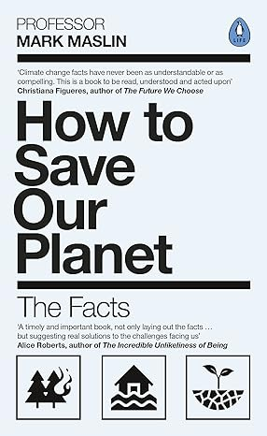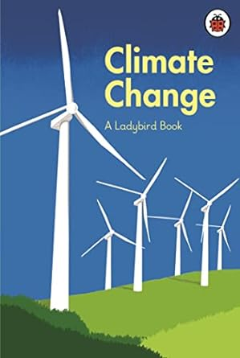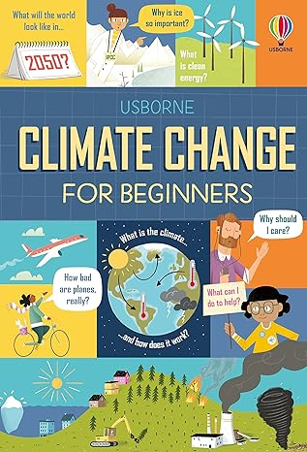

**Project Vision – Aims & Objectives**

* Building a sustainable, climate-resilient and net-zero Walsall together, in a fair and inclusive way, driving community-led action to reduce carbon emissions and climate inequalities
* Long term goal: Walsall to become more resilient and educated on the health and financial impacts from using energy smarter, directly impacting Walsall’s environment
* Will demonstrate how delivering a fabric-first approach with energy awareness makes drastic energy bill savings to ensure people are warm, safe, happy and healthy
* Targeting support to the fuel-poor and the most climate vulnerable communities

Project Aims & Objectives:

1) To improve community climate resilience through multi-stakeholder partnership

2) To enable communities to be more energy efficient ensuring residents are warm, safe, happy and healthy

3) To increase local green jobs and skills opportunities supporting transition to a greener economy

4) To help communities have improved understanding of climate change enabling them to reduce their carbon footprint

5) To ensure more people understand energy use, save money and made home/community energy efficiencies.

**Being Part of the Team**

At Aaina we want to see people grow and succeed ad to thrive in their roles which is firmly aligned with our values. We expect everyone to display the behaviours need to contribute to our vision and purpose. In return we seek to offer an inclusive, rewarding and collaborative environment.

**Staff Benefits**

* 28 days annual leave, plus England public holidays per year (pro rata if part time)
* Mid and annual performance review with development plans
* Access to mandatory and ongoing personal development training
* NEST employer contribution scheme
* Mental Health and Wellbeing support including a trained mental health first aider within the team
* Office closure between Christmas and New Year
* We accommodate school pick-ups and drop offs
* Team building sessions throughout the year
* Mentoring and Coaching opportunities

**JOB DESCRIPTION**

**JOB TITLE:** Sessional Energy and Climate Advice Officer

**REPORTS TO:** CEO

**LOCATION:**  Aaina Community Hub

**SALARY** £12.30 per hour – 16 hours per week

**DURATION** To commence January 2025 – fixed annual contract, reviewed annually based on performance and outputs and outcomes achieved.

**PRIORITY CONTACTS:** Clients who need energy and climate mitigation advice, volunteers, and the project Workstream and Steering Groups.

The Walsall Energy Action Project (WEAP) is a partnership project between Ryecroft NRC, Aaina Community Hub Ltd, Brownhills Community Association, Darlaston all Active, Nash Dom CIC, Walsall Working for Change CIC and Walsall Council.

The National Lottery Community Fund has awarded WEAP project £1.4m to deliver a 3-year project to help people and communities in Walsall fight fuel poverty and climate change. Walsall has the 9th highest levels of in the fuel poverty in England, the WEAP project will help residents to save money on their energy bills and also to understand how to mitigate climate change.

Working as a member of the WEAP project you will engage with targeted participants who are involved with specific projects. In a diverse and busy environment, you will be supporting the community project managers, volunteers and reporting to the project steering and workstream groups. A working knowledge of energy awareness and climate change is desirable however training will be provided. Previous experience within the 3rd sector is also desirable.

**Key Tasks:**

* Delivery 1-2-1 and group energy & climate advice sessions will be to Walsall residents during the project.
* Oversee workshops that will train residents in how to make energy saving kits for their homes.
* Support the training of volunteers to be Energy Advice Champions.
* Support the delivery the delivery of Household Energy and Climate advice visits to the most vulnerable residents.
* To actively support the community project managers monitoring and reporting progress and outcomes.
* To be enthusiastic and use initiative during sessions to keep participants engaged.

**Abilities Skills**

* To possess excellent communication and interpersonal skills
* To possess relevant experience of working with 3rd sector projects and with volunteers.
* Have awareness of Health and Safety when delivering sessions and other legal regulations with respect to projects, participants and the general public.
* Provide a professional service and develop effective working relationships with other staff, volunteers, participants, and external partners.

**Other Essential Requirements**

* An awareness of, and commitment to, equality of opportunity
* Awareness of, and commitment to, confidentiality when handling data
* Be aware of, and assume the appropriate level of responsibility for, safeguarding and promoting the welfare of children, young people and vulnerable adults and to report any concerns in accordance with the organisation’s safeguarding policies.
* Comply with all organisational policy, procedures, and systems.
* Ability to work outside normal office hours.

The sessional Energy and Community Advice Officer will need to flexible, and hours will be allocated to appropriate qualified workers. When appropriate, training will be offered to community support workers to offer development within their roles*.*

**Aaina’s Commitment to Diversity**

Aaina Community Hub is committed to creating a diverse environment and is proud to be an equal-opportunity employer. All qualified applicants will receive consideration for employment without regard to race, ethnicity, religion, gender, gender identity or expression, sexual orientation, national origin, genetics, disability, or age.

**How to apply**

To apply for this post, download the application form, please email completed application form to [**info@aainahub.com**](mailto:info@aainahub.com)

**Recruitment timetable Additional Support / information**

Call **01922 644006** for any further information if you require any assistance or adjustment so that can help with making the application process work for you.

For any questions or to arrange an informal chat about this role, email CEO A’isha Khan at aishakhan@aainahub.com

**Deadline for applications**

Friday 3rd January

**Interviews to be held**

W/C Monday 13th January 2025

**Decision made by**

W/C 20th January 2025