

Job Pack

All you need to know about working for Aaina Community Hub.

**For more information, contact 01922 644006**

**Find us at: https://aainahub.com/**

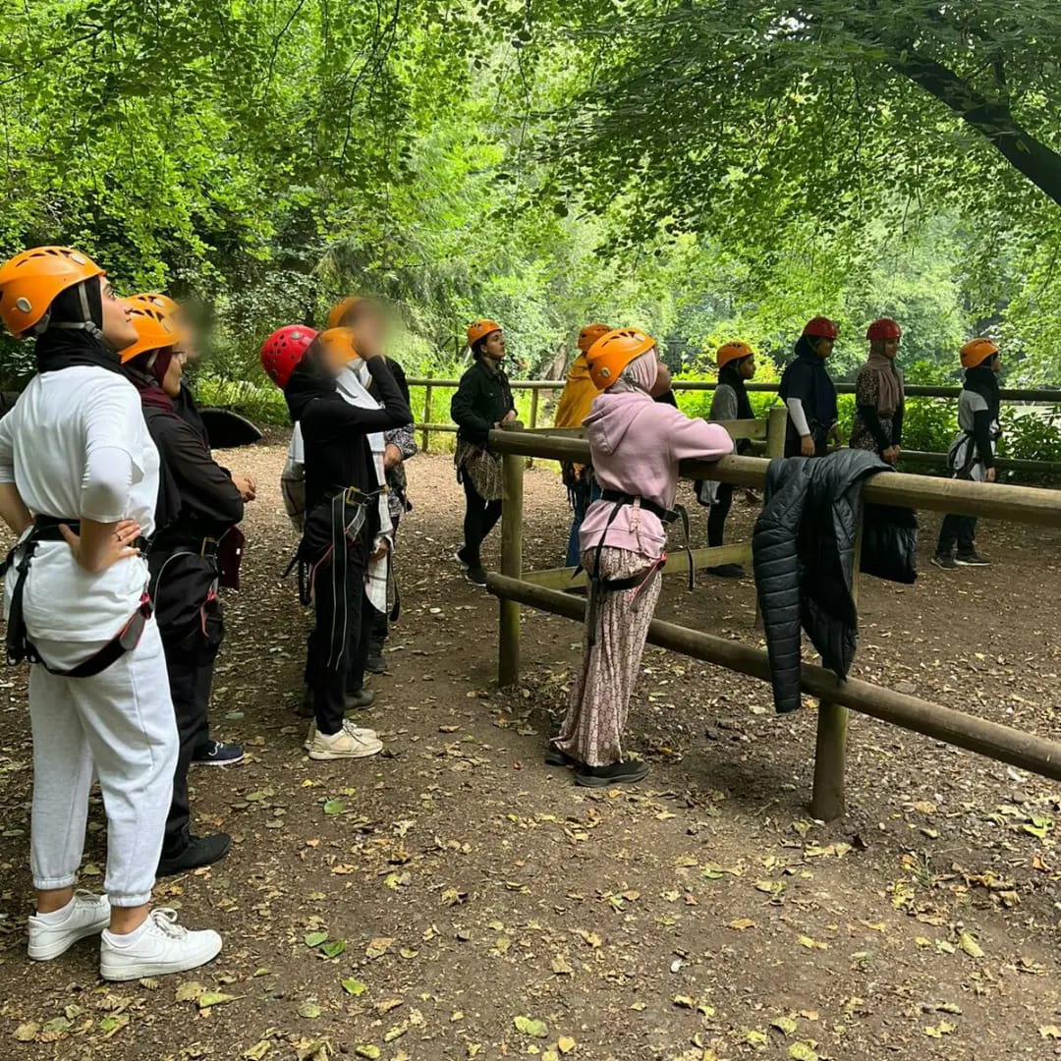

**Introduction**

We are delighted you are considering applying for a role at the Aaina Community Hub. Aaina delivers preventative and intervention focused life-enhancing opportunities for women and children, empowering through education, employment, advice and healthy lifestyles in a safe and supportive environment. We are looking for an enthusiastic person to join our team. This information pack contains important information about Aaina and the specific role you will be applying for. Please read it carefully to learn about the role & company.

Aaina has been delivering services for residents of Walsall since 1997, we specialise in providing access to education and training, accessing employment, support services and community engagement.

**Our Aim**

To play a dynamic role in enhancing quality of life by providing education, work skills and addressing inequalities in a supportive environment leading to improved life chances for the women of Walsall and their families.

**Mission Statement:**

Aaina Community Hub is committed to creating a nurturing environment where women and their families can thrive together. Our mission is to promote inclusivity, empower personal growth, and build a strong community foundation. We believe in the power of unity and the potential of every individual to make a positive impact, ensuring every voice is heard and every dream has the chance to flourish.

**Our Values**

* Inclusive - To ensure Aaina Community Hub fosters an inclusive environment that welcomes and supports all women and families accessing our services and space
* Ethical / integrity – Our ethical approach to service delivery is reflective in our integrity and commitment to transparency and honesty.
* Equitable – We are committed to recognising individual strengths and capabilities and accommodating beneficiaries accordingly
* Empowering – We recognise women’s power and provide them with the space and platform to reclaim this in a safe and supportive environment
* Self-Worth – instilling self-respect and self-worth in beneficiaries is fundamental for them to thrive and lead independent lives with self-belief and strength
* Opportunities – Aaina is committed to making opportunities accessible to beneficiaries that develop skills, wellbeing and prosperity and lead to individual progress.

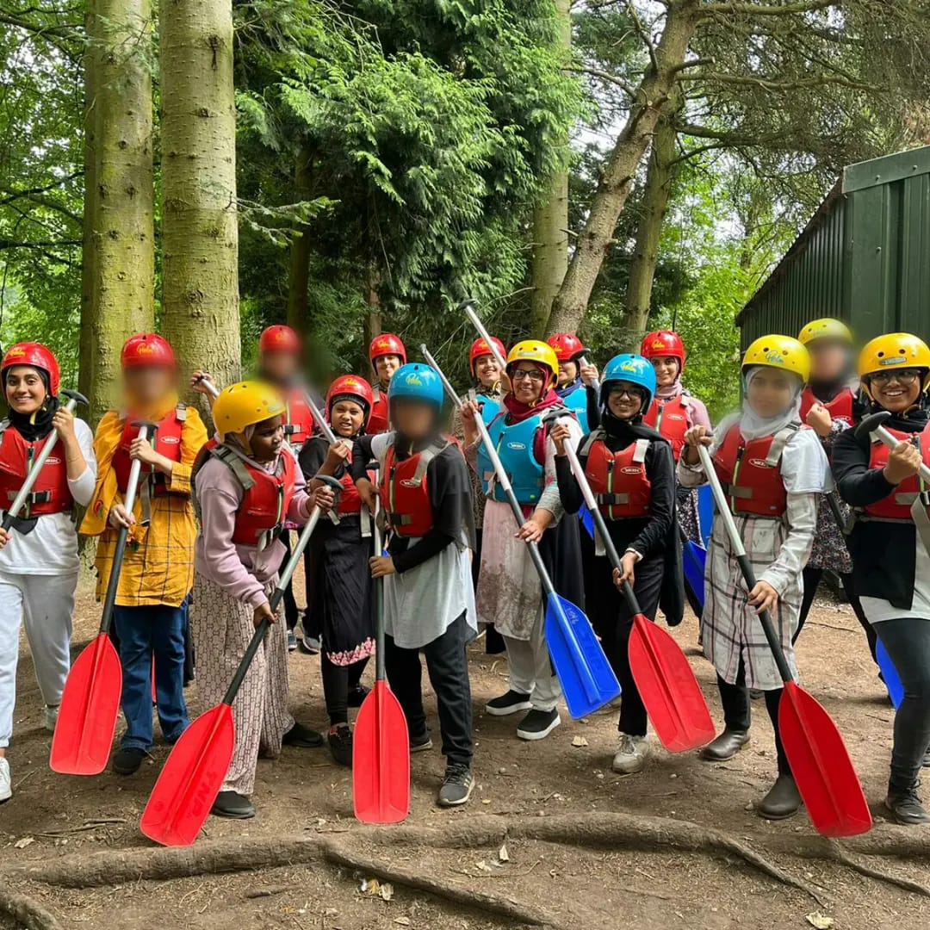

Aaina has secured Youth Futures Foundation funding for a 4-year programme as part of the Connected Futures programme.

Aaina has identified three key objectives for the young people that will be targeted:

* An increase in Walsall’s 16-24 employment rate for young people with Bangladeshi and Pakistani heritage.
* Greater diversity of opportunity, including access to progression, as a result of changes in employer practice.
* Increased access to skills and training opportunities.

The aim will be to create employer-led momentum for change, through building relationships with employers, supported by wider strategic alliances. This partnership will broker direct engagement between employers and young people in the community – both to access opportunities and to influence thinking and practice.

This will be achieved through three workstreams:

* **Employer engagement** – Building ownership among local employers of the business benefits of a diverse workforce and the practical steps they can take to develop more inclusive employment practices.
* **Youth voice and engagement** – Providing outreach and brokerage with young people with Bangladeshi and Pakistani heritage, including those currently in low-paid employment, to promote access to training and progression opportunities.
* **Systems engagement** – Tackling systemic barriersin schools, colleges / training providers or families, as well as mainstream employment support, which limit young people’s exposure and/or access to opportunities.

We are keen to recruit a dynamic and committed team that will commence delivery from January 2024, staff will be primarily based at The Digital Hub on St Georges Street in Walsall.

**Being Part of the Team**

At Aaina we want to see people grow and succeed ad to thrive in their roles which is firmly aligned with our values. We expect everyone to display the behaviours need to contribute to our vision and purpose. In return we seek to offer an inclusive, rewarding and collaborative environment.

**Staff Benefits**

* 28 days annual leave, plus England public holidays per year (pro rata if part time)
* Mid and annual performance review with development plans
* Access to mandatory and ongoing personal development training
* NEST employer contribution scheme
* Mental Health and Wellbeing support including a trained mental health first aider within the team
* Office closure between Christmas and New Year
* We accommodate school pick-ups and drop offs
* Team building sessions throughout the year
* Mentoring and Coaching opportunities

**Job Description**

**Position Title:**  Youth Engagement Co-ordinator

**Salary:**  £28,000.00 per annum

**Position Type:**  Full-time, 37 hours per week

**Duration** Four-year programme to commence January 2024, fixed

annual contract reviewed annually based on performance

and outputs and outcomes achieved

**Location:**  Digital Hub, George Street. Walsall

**Reports To:**  Partnership Manager

**Job Summary**

The Youth Engagement Co-ordinator will be responsible for overseeing the part time outreach officers and will work with partner organisations to support youth engagement and outreach activities aimed at Pakistani and Bangladeshi youth aged 16 to 24 years.

The Youth Engagement Coordinator will play a pivotal role in empowering Pakistani and Bangladeshi youth, helping them to achieve their full potential by providing targeted programs and support, the Co-ordinator will foster a sense of community, build leadership skills, and create pathways for personal and professional success.

The Co-ordinator will develop, implement, and evaluate programs that foster youth participation and engagement within the community. This role requires a passionate and dynamic individual who can connect with youth, understand their needs, and create meaningful opportunities for their growth and involvement.

**Key Responsibilities**

**Program Implementation:**

* **Youth Engagement:** Work with partners to develop culturally relevant activities that address the specific needs and interests of Pakistani and Bangladeshi youth to address unemployment and raising aspirations.
* **Plan Activities:** Organize workshops, events, and activities that promote personal, educational, and professional development.
* **Job Fairs:** Organise quarterly community job fairs across the Borough to engage the target group

**Outreach and Engagement:**

* **Community Outreach:** Establish and maintain relationships with community organizations, schools, and other stakeholders to promote the program.
* **Recruitment:** Actively recruit youth participants for the Youth Panel through various channels such as social media, community events, and school visits.
* **Engagement:** Foster a welcoming and inclusive environment that encourages youth participation and engagement.

**Mentorship and Support:**

* **Individual Support:** Provide one-on-one support and mentorship to youth, helping them navigate personal and academic challenges.
* **Group Facilitation:** Lead group discussions and activities that encourage peer support and community building.

**Monitoring and Evaluation:**

* **Data Collection:** support the collection and analysing of data to monitor program effectiveness and impact.
* **Reporting:** Prepare regular reports on program activities, outcomes, and areas for improvement.
* **Feedback:** Gather feedback from participants and stakeholders to continuously improve the program.

**Communication and Advocacy:**

* **Promotion:** Promote the program through newsletters, social media, and other communication channels.
* **Advocacy:** Advocate for the needs and interests of Pakistani and Bangladeshi youth within the organisation and the broader community.

**Skills and Qualifications**

**Education and Experience:**

* **Education:** A bachelor’s degree and similar qualification in a related field to the position description.
* **Experience:** Minimum of 2 years’ experience in youth work, community outreach, or a related field. Experience working with Pakistani and Bangladeshi communities is highly desirable.

**Skills:**

* **Cultural Competence:** Strong understanding of the cultural, social, and educational contexts of Pakistani and Bangladeshi youth.
* **Communication:** Excellent verbal and written communication skills, with the ability to connect effectively with youth and community stakeholders.
* **Leadership:** Demonstrated leadership and group facilitation skills.
* **Organisational:** Strong organisational and time-management skills.
* **Technical Proficiency:** Proficiency in MS Office Suite (Word, Excel, PowerPoint).
* **Organised**: Experience in organising events, particularly job fairs or networking opportunities aimed at youth.
* **Ability** to work collaboratively with employers and community organisations to enhance the quality and relevance of job opportunities available at the events.
* **Knowledge** of the local labour market and the specific challenges faced by young people in accessing employment.

**Personal Attributes:**

* **Empathy:** Genuine interest and empathy for the challenges faced by Pakistani and Bangladeshi youth.
* **Passion:** Passionate about youth development and community engagement.
* **Flexibility:** Ability to work flexible hours, including evenings and weekends, as required.
* **Motivation:** Self-motivated and able to work independently as well as part of a team.

**Aaina’s Commitment to Diversity**

Aaina Community Hub is committed to creating a diverse environment and is proud to be an equal-opportunity employer. All qualified applicants will receive consideration for employment without regard to race, ethnicity, religion, gender, gender identity or expression, sexual orientation, national origin, genetics, disability, or age.

**How to apply**

To apply for this post, download the application form, please email completed application form to [**info@aainahub.com**](mailto:info@aainahub.com)

**Recruitment timetable Additional Support / information**

Call **01922 644006** for any further information if you require any assistance or adjustment so that can help with making the application process work for you.

For any questions or to arrange an informal chat about this role, email CEO A’isha Khan at aishakhan@aainahub.com

**Deadline for applications**

Friday 3rd January

**Interviews to be held**

W/C Monday 13th January 2025

**Decision made by**

W/C 20th January 2025